Excel Assignment - 16

*1. What is a Macro? How is it useful in excel or in your daily work?*

1. A macro is shorthand for a programming term: macroinstruction.
2. In the most basic terms, a macro is a way to automate simple tasks.
3. They can be used in a variety of ways, but most of us will learn to love them as helpful shortcuts in Microsoft Excel.

***How do Macros Work?***

When ywe want to use macros to handle repetitive tasks for us, this first thing we do is ‘record’ a macro. Basically, this means that our computer will record every step you take during a task. Once we’ve recorded all the steps you take, our computer will save this and next time we need to do the same process, we just ‘run’ the macro, and it will simply repeat every step we just did (and we mean every step – when we’re recording macros it’s essential to get our process right or it could cause issues).

It’s a great time saver, and helps reduce mistakes as the macro will simply perform the pre-programmed steps each time so it reduces human error.

Macros simply repeat actions it’s important that whatever steps we follow are always going to be the same. If the data is in a different column on the spreadsheet we copy data from, that could cause havoc. So, while macros are a great time saver and can help decrease errors, they aren’t an excuse to not pay attention to the data you’re working with.

**Uses of Macro :-**

1. Data related tasks include everyday Excel tasks to cleanup and format data.

2. We can also automate tasks across worksheets and workbooks.  This includes things like listing all the sheets, creating a table of contents, hiding specific sheets, opening and closing workbooks, and more.

3. Pivot tables are an amazing tool in Excel.  They can also be time consuming to create, format, update, and maintain.  Fortunately, we can automate just about every property and action with pivot tables using VBA macros.

4. Userforms are windows that open over Excel with interactive controls.  They make our spreadsheets easier for other users to use.  The userforms can be created and modified in the VB Editor.

5. We can also automate more complex processes with macros & VBA.  This includes creating systems to create, update, or modify several Excel files.

*2. What is VBA? Write its full form and brieﬂy explain why VBA is used in excel?*

VBA full form is “Visual Basic for Application” .

It is a human-readable and editable programming code that gets generated when you record a macro. Today, it is widely-used with other Microsoft Office applications such as MS-Word, MS-Excel, and MS-Access.

VBA allows you to automate various activities in Excel such as generating reports, preparing charts & graphs, doing calculations, etc. This automation activity is also known as Macro.

VBA helps to build customized applications and solutions to enhance the capabilities of these applications.

The advantage of this facility is that you don't have any need to install visual basics on your desktop. And installing Office will ultimately help you to achieve the purpose. Also, you can build very powerful tools in MS Excel using linear programming.

VBA can use in all office versions, from MS-Office 97 to MS-Office 2019 and with any available latest versions. Among VBA, Excel VBA is the popular one.

VBA is a high-level language. VBA is a subset of Visual Basic 6.0 BASIC stands for Beginners All-Purpose Symbolic Instruction Code.

here are several principal reasons to consider VBA programming in Excel :-

**Automation and repetition :-**

VBA is effective and efficient when it comes to repetitive solutions to formatting or correction problems. For example, Have you ever had to reformat multiple tables that were pasted into Excel?

If you have a change that you have to make more than ten or twenty times, it may be worth automating it with VBA. If it is a change that you have to do hundreds of times, it certainly is worth considering. Almost any formatting or editing change that you can do by hand, can be done in VBA.

**Extensions to user interaction :-**

There are times when we want to encourage to interact with the excel in a particular way that is not part of the standard application. For example, we want to prompt users to take some particular action when they open, save, or print a document.

**Doing things another way :-**

* VBA uses simple English statements to write the instructions.
* Creating the user interface is a drag, drop, and align the graphical user interface controls in VBA.
* VBA is very simple to learn and required basics programming skill.
* VBA enhance the functionality of excel by allowing you to make excel behave according to your need.

***Application of VBA***

You think why to use VBA in Excel as MS-Excel itself provides loads of inbuilt functions.

MS-Excel provides only essential inbuilt functions that may not be sufficient to perform complex calculations. Under such circumstances, VBA becomes the most transparent solution.

For example, Using Excel's built-in formulas is tough to calculate the monthly repayment of the loan. But, it's easy to program a VBA for this kind of calculations.

*3. How do you record a macro?*

1. **Before recording a macro**

Macros and VBA tools can be found on the Developer tab, which is hidden by default, so the first step is to enable it.

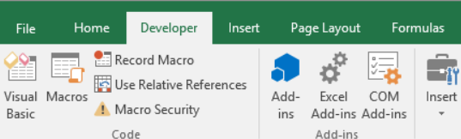

1. **Record a macro**
2. In the Code group on the Developer tab, click Record Macro.
3. Optionally, enter a name for the macro in the Macro name box, enter a shortcut key in the Shortcut key box, and a description in the Description box, and then click OK to start recording.

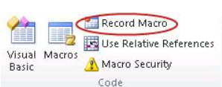

1. Perform the actions we want to automate, such as entering text or filling down a column of data.
2. On the Developer tab, click Stop Recording.

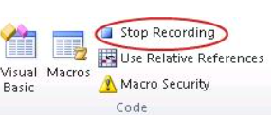

*Write detailed steps to create a macro to automatically make the following table in bold and to create borders for it in excel.*

hi 78

hello 69

ineuron 45

Below steps are to make table bold and to create borders for in excel :-

1. First, we need to specify the range or the cell where to apply the border and to make the letters bold usig the range object. Here cell range is C2 to C4

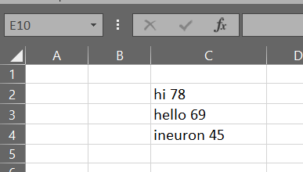

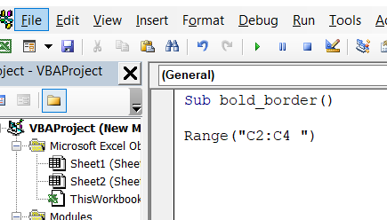

2. After that, type a dot (.) and then select the “Borders” property from the list of properties and methods. Next, specify the border index from the contants avaiable. specify the line style using the “LineStyle”. I’m using the “xlContinuonus” as the line style.

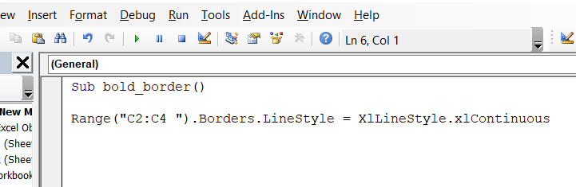

3. Now, We have to write line for making the text bold in the table. So, again we start with writing the range C2 to C4. After than, type dot(.) and then select “Font” property. Then again type dot (.) and select property as “Bold” and write as “= True” . Our macro is ready to run now.

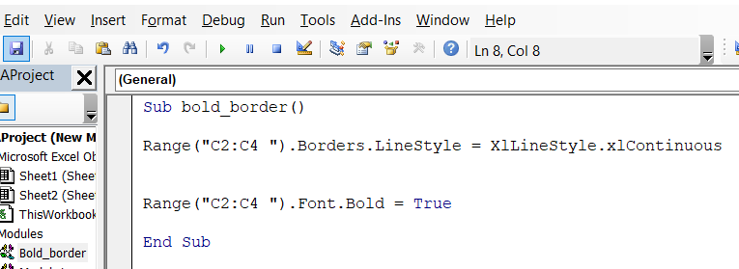

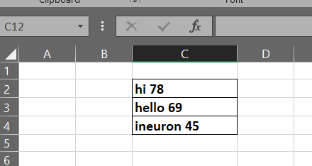

*4. What do you mean when we say VBA Editor?*

* Visual Basic Editor is also called the VBA Editor, VB Editor or VBE Editor.
* Visual Basic Editor is a separate application. It is a part of Excel and opens whenever you open an Excel workbook. By default, it's hidden, and you have to activate to access it.
* Visual Basic for Applications Editor is a very powerful tool. It is an interface for creating scripts.VBA Editor is the place where you keep the VBA code.

There are multiple ways to get the code in the VBA Editor, such as:

1. When we record a Macro, it creates a new module in the VBA Editor automatically and inserts the code in that module.
2. We can manually write VBA code in VBA Editor.
3. Also, we can copy a code from some other workbook or some other source such as the internet and paste it in the VBA Editor.

*5. Brieﬂy describe the interface of a VBA editor? What is properties window? And what is watch window? How do you display these windows?*

The basic VBE window can be divided in the following 6 sections, all of which I explain below. In reality, **there are more components** than those which appear in this screenshot (such as the Locals and Watch Windows)

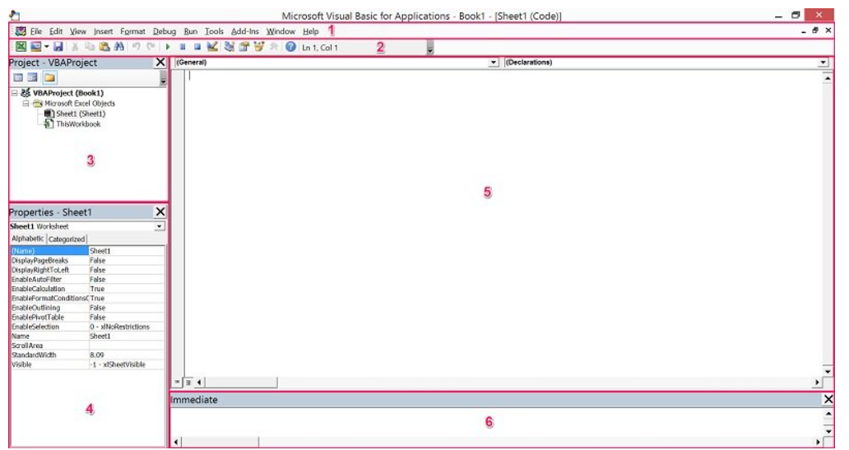

* Component #1: Menu Bar : The menu bar, basically, contains several drop-down menus. Each of the drop-down menus contains commands that you can use to interact and do things with the different components of the Visual Basic Editor. Several commands have a keyboard shortcut that is displayed at that point.
* Component #2: Toolbar : The toolbar that appears in the screenshot above is called the Standard toolbar. This is the only toolbar that the Visual Basic Editor displays by default. There are, however, 3 other basic toolbars:

1. The Debug toolbar.
2. The Edit toolbar.
3. The UserForm toolbar.

In addition to the above, the VBE gives you the possibility to customize the toolbars in several ways.

* Component #3: Project Window / Project Explorer :

The Project Window, also known as the Project Explorer, is useful for navigation purposes. This is the section of the Visual Basic Editor where you'll be able to find every single Excel workbook that is currently open. This includes add-ins and hidden workbooks. More particularly, each Excel workbook or add-in that is open at the moment appears in the Project Explorer as a separate project.

A project is a set of modules. A project can be seen as “a collection of objects arranged as an outline”.

A node called “Microsoft Excel Objects” always appears in any project. This node usually contains 2 types of objects:

#1: Each worksheet in the relevant Excel workbook. In other words, each of the worksheets is considered a separate object.

#2: The Excel workbook itself, called “ThisWorkbook”.

The Modules node appears when the project contains VBA modules.If the project contains UserForm objects, which are used to create custom dialog boxes, the Project Explorer displays a node called “Forms”. A project can also contain class modules (modules that define a class) and, in that case, the Project Window displays a node called “Class Modules”. Finally, if a project has references, there is a node called “References”.

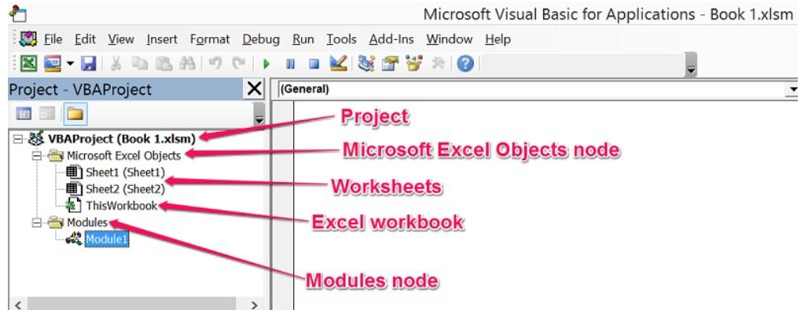

* Component #4: **Properties Window :**

The Properties Window displays the properties of the object that is currently selected in the Project Explorer and allows you to edit those properties. Just as with the Project Window, We can hide or unhide the Properties Window. We're likely to work with the Properties Window, particularly in the context of creating UserForms. If you're just beginning to use the VBE, you probably won't need this window too much.

* Component #5:Programming Window / Code Window / Module Window

The Code Window of the Visual Basic Editor is where your VBA code appears, and where you can write and edit such code. At the beginning, though, the Programming Window is empty as in the screenshot above.

There is a Code Window for every single object in a project. You can access the window of a particular object by going to the Project Explorer and doing any of the following:

* Double clicking on the object. The main exception to this rule are UserForms. If you double-click on a UserForm, the Visual Basic Editor displays the UserForm in Design view, a topic I'll cover in future tutorials.
* Selecting the object and, then, clicking on “Code” in the View menu.
* Selecting the object and clicking on the View Code icon that appears at the top of the Project Explorer.
* Right-clicking on the object and selecting “View Code”.
* Component # 6: Immediate Window :

The main purpose of the Immediate Window is to help you noticing errors, checking or debugging VBA code.The Immediate Window is, by default, hidden. However, as with most of the other windows, you can unhide it.

*6. What is an immediate Window and what is it used for?*

Immediate Window :

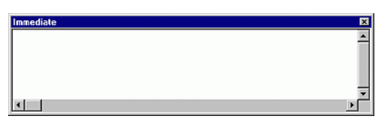

Immediate Window allows us to:

1. Type or paste a line of code and press ENTER to run it.

2. Copy and paste the code from the Immediate window into the Code window, but does not allow us to save code in the Immediate window.

3. The Immediate window can be dragged and positioned anywhere on your screen unless we have made it a dockable window from the Docking tab of the Options dialog box.

4. We can close the window by selecting the Close box. If the Close box is not visible, double-click the title bar to make the Close box visible, and then select it.

The main purpose of the Immediate Window is to help us noticing errors, checking or debugging VBA code.The Immediate Window is, by default, hidden. However, as with most of the other windows, we can unhide it.